Clubroot (Plasmodiophora Brassicae)

This fungal disease is one of our most problematic as it takes a while before you realise that you have it and have to do something about it to prevent its spread.
Once you have it, it will be with you for years.
However, even if your soil is infected, it is still possible to grow acceptable crops.

What plants are attacked by clubroot?

Brassicas - Cabbages, cauliflowers, Brussels sprouts, radish, mustard, turnips, swedes, broccoli, kale, calabrese and kohl rabi are all susceptible.
Chinese cabbage and other oriental cabbage family crops are especially vulnerable.
Weeds will also support the disease, such as shepherd’s purse, hairy bitter cress and charlock.
Flowers - Wallflower, stock and alyssum can suffer from clubroot, too.

How do I recognise clubroot?

The plants wilt, appear stunted and go grey/blue as their roots are destroyed.
The leaves droop when other unaffected plants are still looking healthy.
They typically recover from the wilting at night.
Swollen roots with ‘finger and thumb’ like projections are typical signs.
When the roots are highly galled, the plasmodia produce more spores that are released into the soil when the galls break up and decay.
Infected roots soon rot into a foul-smelling mass, discharging more spores into the soil.
Galls vary from lumps covering the swollen bulbs on turnips and swedes to finger- like projections on fibrous-rooted brassicas.
Some of the most spectacular galls occur on Chinese cabbage and other oriental greens.

Can plants be cured?

NO, once your plants are attacked, there is no cure.

How do I remove and dispose of the plants ?

Carefully lift and remove the diseased plant making sure not to leave any root in your soil.
Give that soil area a good liming.
Although the plant tops are unlikely to be contaminated it is safer not to compost but to remove from site and dispose of the root into non-recyclable waste.
Green waste disposal of the root means that you are spreading the possibility of giving clubroot to some other gardeners, as municipal waste is now a major component of proprietary compost.

Can clubroot be prevented?

Wet and acid soil are the favoured conditions of clubroot.
Improving drainage will help. Acid soils can be made more alkaline and much less favourable to clubroot infection by the addition of lime or chalk, particularly at planting out time. Lime is relatively cheap, so this is the most economical way to minimise the possibility of clubroot.

Are transplants at risk?

Transplants are just as vulnerable as seed-raised plants. Give them the best start by raising them in known clubroot-free soil. Ideally, raise them in soil less compost, as this is almost certain to be free of the disease. The bigger the container the better. A 15cm pot is ideal, but can be expensive in compost if you have a lot of plants to grow.
Plant out without disturbing the root ball and water well until the plants are established.
If you haven’t grown the plants yourself question your supplier and examine the rootball closely before planting out.

Are there any chemicals to treat it?

If you use bare-root transplants, you can dip the roots prior to planting in thiophanatemethyl-based treatments. Protection is not total, but it can be helpful, especially if you lime and make sure your plot is well drained as well. There are no organically acceptable chemicals available to control clubroot.
Some gardeners rinse bare rooted plants in limed water at planting out time.

How did I get clubroot in the first place?

Clubroot can get into gardens on contaminated seed, but this is most unusual.
The most common method of spread seems to be on infected transplants or tools contaminated from gardens with the disease.
Don’t borrow tools or buy soil-raised transplants from unknown sources.
Another source of infection is contaminated manure. If you can, check that manure does not come from beasts fed on root crops or vegetable waste.
Another source that we are convinced about is proprietary compost.
We know that larger proportions of recycled waste are being used in the manufacture of composts. Despite manufacturers claims that the composting process generates temperatures that will kill the spores, we are not convinced and the manufacturers will not guarantee that their composts are disease free. We do have several known examples of clubroot contaminated plants coming out of proprietary compost.
No one supplier is known to be a guaranteed disease free supplier.

If my ground is infested, will I have to give up growing cabbage-family crops?

No, many gardeners keep growing brassicas in the presence of the disease.
They soldier on adopting the practices described earlier.
There is no single, simple remedy however making sure that your soil at planting out time is alkaline not acidic will help. There are some varieties that claim to be clubroot resistant (resistant to, not free of).

See photo on next page.

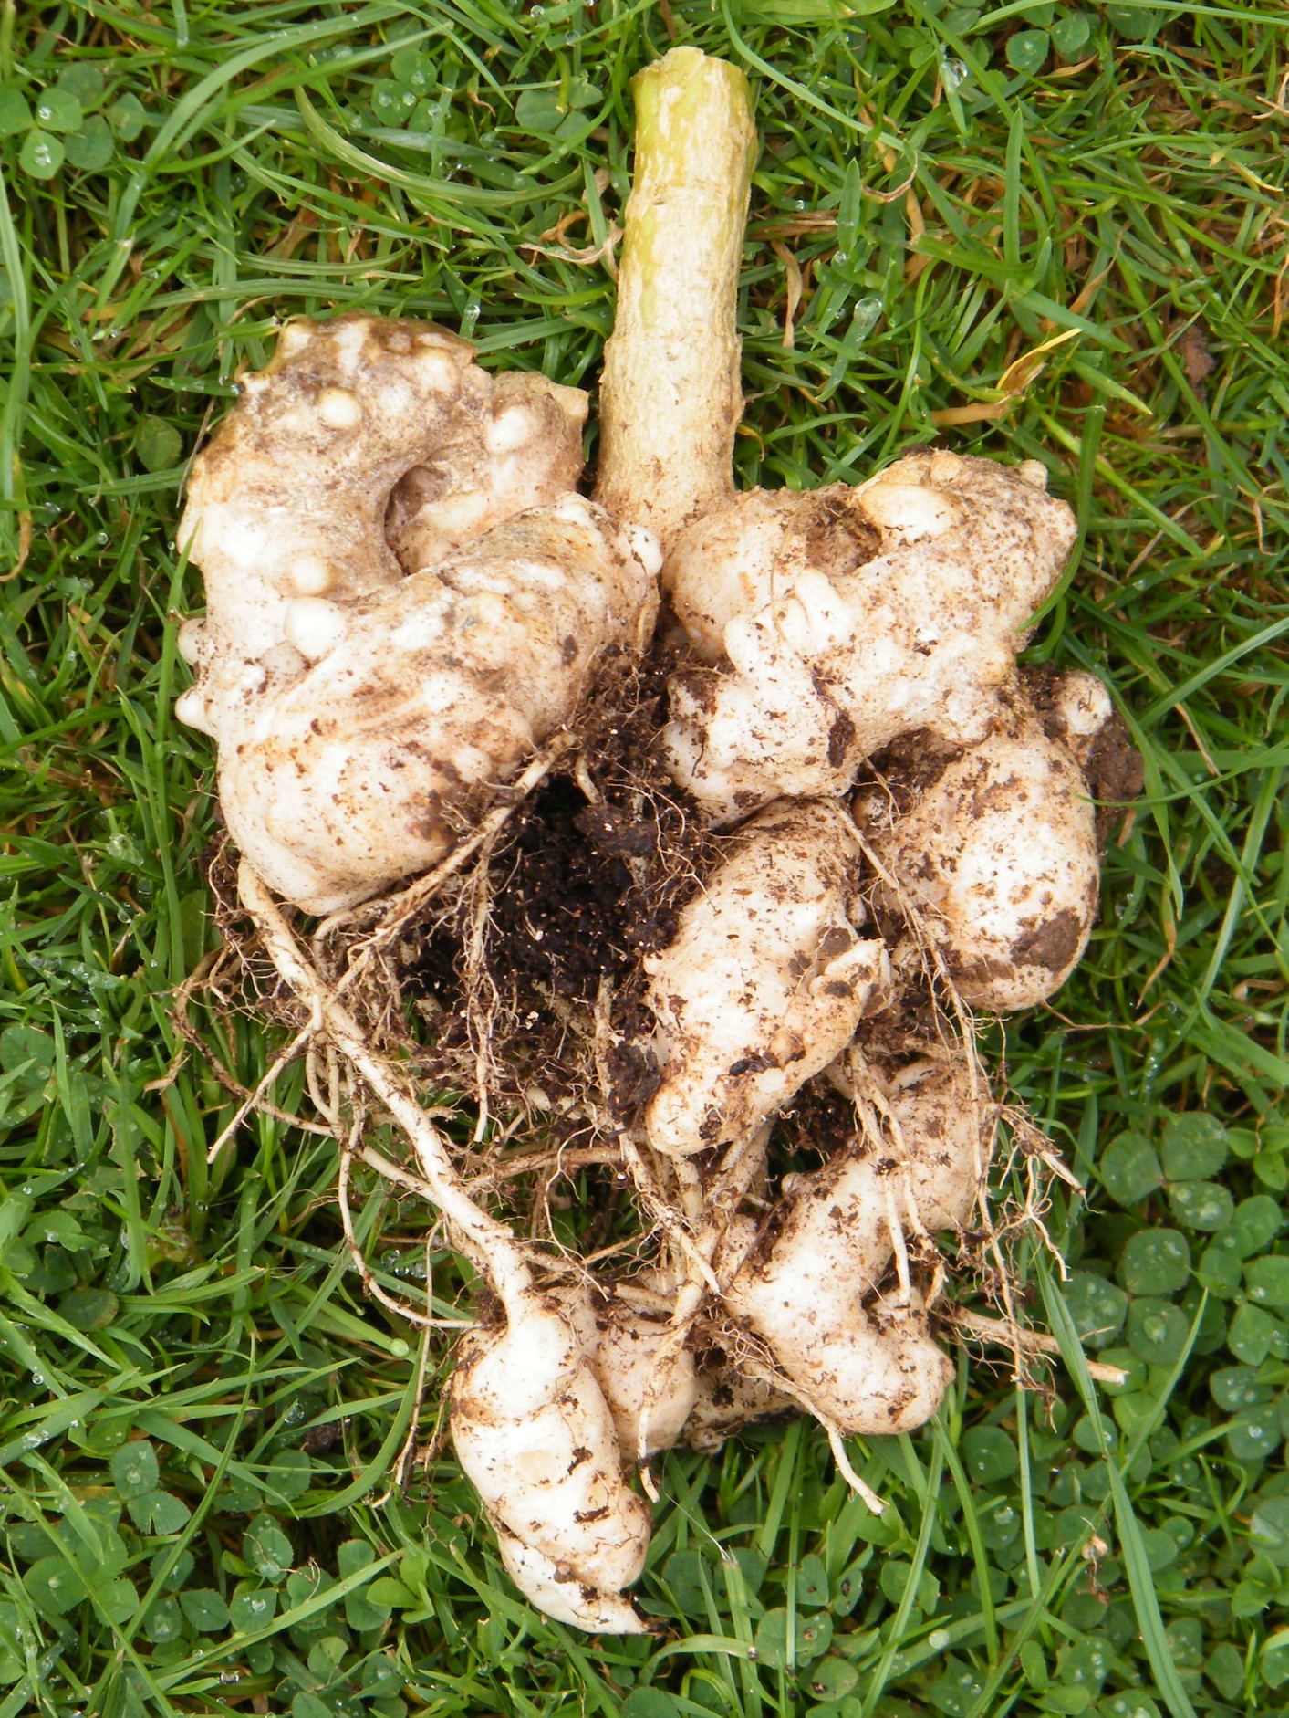

An example of severe clubroot in Sprouting Broccoli- Dated 15 July 2015

