Bee-friendly plants for allotments by Kath Webb
Our new bee hive is alive and buzzing! We can help to keep our new stripy friends happy around Lower Down Rd allotments by giving them plenty of plants to visit.
According to the beekeeper who installed the beehive there are two things the bees need. Early on in the season they look for pollen to build up the brood size. Later the bees need nectar for energy to sustain them.
What can you do to help?
Plant flowers and herbs which are rich in nectar and pollen. Even if we only planted a single type of insect-friendly plant this would make a difference. A couple of species might help to provide a food source for bees over a longer season. Obviously, the more you plant the better.
How will it benefit you?
- In return for food, the bees will ensure you have a successful crop by pollinating your fruit and vegetables.
- Your plot will look more cheerful and you will be able to cut some flowers to brighten up your home too.
- Encouraging more insects will also help to control the amount of ‘bad’ insects which might damage your crop. For example, nasturtiums help repel white fly and attract black fly away from cabbages and broad beans.
- You are doing something positive to help the overall bee population.
What should you plant?
The general rules are to choose native, wild flowers and avoid double-headed flowers as these contain little nectar. Here are some bee-friendly flowers most suited to allotments:
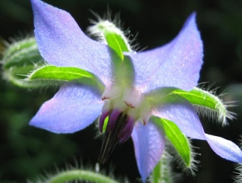
Borage
A very attractive plant for honeybees and bumblebees. Apparently it refills with nectar every 2 minutes! The flowers are also nice in salads. The leaves can also be eaten when young. Sow in April/May directly where they are to flower. Borage likes a sunny location and fertile soil. It self-seeds readily so choose a corner of your plot.

Phacelia
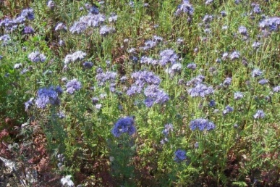
This is a nectar-rich plant which is irresistible to bees. It also has the advantage of being a green manure, which can be dug into the soil before flowering to add fertility. Sow March to September.

Cosmos
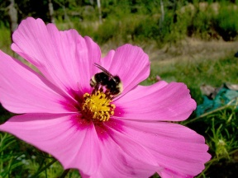
These lovely flowers provide nectar and pollen for bees. They like a sunny position and will keep flowering into late-summer and autumn. Sow direct in late-April, or indoors in March to transplant later.

Cape daisy (Arctosis fastuosa)
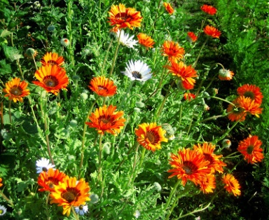
These are really easy to grow and very attractive to hoverflies and bees. Sow in April/May where they are to flower. They will flower from July onwards. They grow particularly well in dry soils so a great choice if we’re lucky enough to have a good summer!

Sunflowers
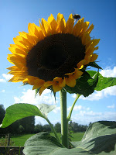
Bees and bumblebees love these huge flowers for their nectar and pollen. Sow straight into the soil in April/May, or start in pots earlier.
Poached-egg plant
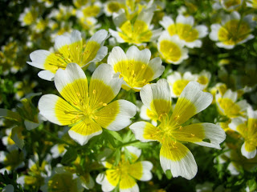
Bees and hoverflies love this plant. It’s low-growing so ideal for growing around your fruit bushes. It can be invasive but is weeded out easily or can be dug in like a green manure. Can also be sown around broad beans to encourage ladybirds.
Other bee-friendly plants
Flowers.
Nasturtium, lavender, red clover (also a green manure), honeysuckle, poppy, cornflowers.

Fruit and veg.
Courgettes, raspberries, runner beans and squash are also loved by bees.

Bulbs.
These are easy to put around your plot. Early spring ones like crocus and grape hyacinth are a great food source for bees just coming out of hibernation.

Herbs. It doesn’t just have to be flowers. Bees love herbs too.
- Try chives - allow these to flower and cut some stems for yourself.
- Rosemary – a great early food source for bees.
- Comfrey – you can also make a potent feed and fertiliser from the leaves.
- Also try marjoram, sage, thyme, lemon balm, angelica and fennel.
What else can you do?
- Grow plants by your shed. You could plant climbing plants like honeysuckle, ivy and clematis. Allow ivy to clamber up your shed. This will provide food for bees, hiding places for butterflies and moths, as well as nest sites for birds.

- Choose chemicals carefully and reduce the amount that you use. (Some pesticides can kill the bees).

- Don’t spray plants that are in flower.

- Only spray when the bees are inactive, such as late in the evening.

Some further references

Phacelia - http://www.greenmanure.co.uk/seeds/phacelia-green-manure-seeds/

RHS - http://www.rhs.org.uk/Media/PDFs/Advice/Plants-for-bees

